Technical Specification

Plugin Name: The Rocket

Type: Transition / Build-Up Effect Plugin

Formats: VST, VST3 / AU / (AAX if possible -we have certificate )

(macOS, Windows)

1. Product Philosophy
The Rocket is designed as a one-knob transition plugin for end users, while internally providing a full modular FX environment for sound designers and preset creators.

Key Principle:
- End user UI → extremely simple
- Internal version → maximum flexibility and control

2. Interface Versions

2.1 Final User Interface (End User Version)
In the final public version, users have access to ONLY:
- Amount knob (Main Macro Controller)
- Preset selector
- (Optional: Preset next / previous buttons/ window with presets list like in demo version that we provided)
⚠️ No individual FX controls are visible to the end user.
Amount knob controls everything:
- FX intensity
- Transitions
- Build-ups
- Sweeps
- Overall mix behavior
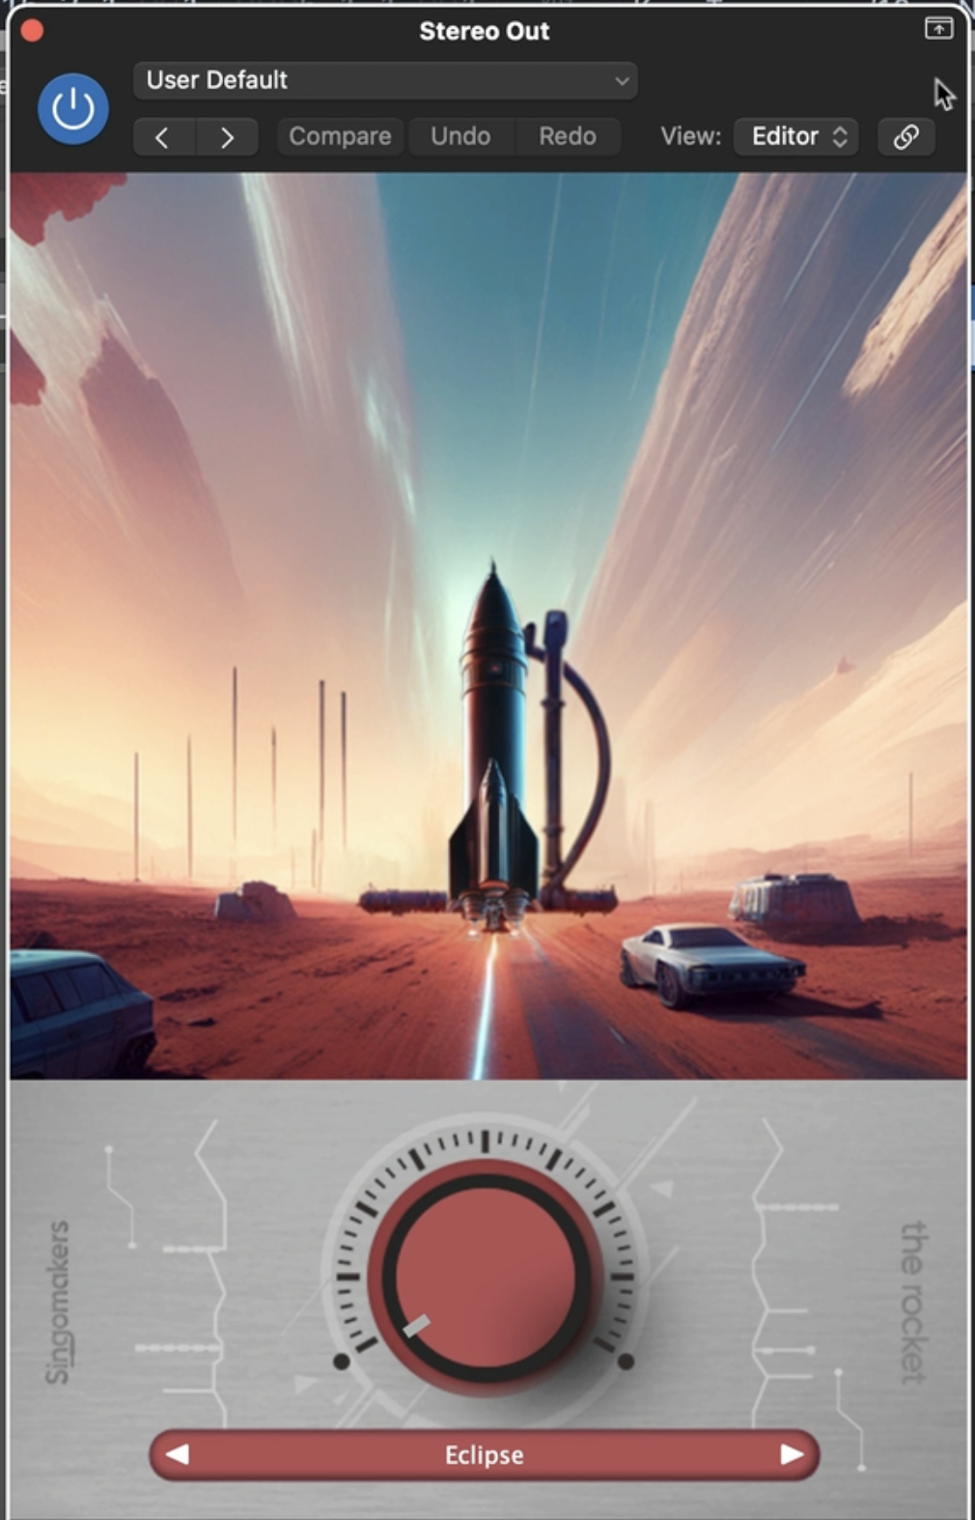

2.2 Internal Version (Preset Designer / Developer Mode)
The Internal Version is used only for:
- Preset creation
- Sound design
- Fine-tuning transitions
It exposes full control over:
- All FX modules
- Modulation system
- Effect order (routing)
- Global Mix behavior
This version is NOT visible to end users.

Example of preset creator that we had from another programmer (no complex UI like here is needed, it could be just basic knobs with titles, sound quality is more important)

3. Effect Chain & Routing (Internal Version)

3.1 Modular FX Chain
In the internal version, effects must be:
- Reorderable via drag & drop or similar mechanism
- Enabled / disabled per preset
- Processed in series according to user-defined order
Example chains:
Filter 1 → Distortion → Delay → Reverb → Filter 2
Reverb → Filter → Delay → Flanger →Bitcrusher → Filter 2
Noise → Ring Mod → Filter → Reverb...
And etc.
This is critical for achieving different transition characters.

3.2 Global Mix
The internal version must include a Global Mix control:
- Controls overall Dry / Wet balance of the entire FX chain
- Prevents abrupt appearance of processing
- Ensures smooth transitions when automating the Amount knob
Global Mix requirements:
- Assignable to the Main Macro
- Supports positive and negative modulation and Value of it
- Multiplu controls could be selected for each plugin
Example behavior:
- Amount = 0 → Mix = 0% (dry signal)
- Amount = 100% → Mix = 100% (fully wet)
Or inverted if desired.

4. Macro & Modulation System (Updated)

4.1 Main Macro (Amount)
- One Main Macro Controller called Amount
- This macro is the ONLY control exposed in the final UI

4.2 Internal Modulation Mapping
In the internal version:
- Any parameter can be assigned to Amount
- Each assignment must include:
  - Modulation Amount
  - Direction:
    - Positive
    - Negative
  - Optional min/max range
This applies to:
- FX parameters
- Generator parameters (Tone/pitch, Volume)
- Global Mix
- Individual module Mix controls

4.3 Example Internal Mapping
When Amount increases:
- Filter cutoff ↑
- Reverb size ↑
- Delay feedback ↑
- Distortion mix ↑
- Bitcrusher mix ↓
- Global Mix ↑
This allows complex musical transitions using a single macro.

5. Noise & Tone Generators (Internal Routing)
Noise and Tone generators:
- Exist as independent sound sources
- Can be:
  - Mixed into main signal
  - Routed through the same FX chain
- Fully modulatable by Amount
Used primarily for:
- Risers
- Sweep ups
- Energy builds before drops

6. Preset System (Updated)
Each preset must store:
- FX chain order
- Enabled FX modules
- All macro assignments
- Positive / negative modulation values
- Global Mix behavior
- Generator settings
Presets define the entire behavior of the Amount knob.
After switching presets all parameters of all effects should reset.

7. Automation & Safety
- Amount knob must be:
  - Fully automatable
  - Click-free
  - Smoothed internally
- Global Mix ensures:
  - No sudden jumps
  - No harsh FX engagement
- Preset switching must be pop-free

8. Summary (For Developer)
End User sees:
- 1 knob (Amount)
- Preset menu
Internal version provides:
- Full FX control
- FX reordering
- Advanced modulation
- Global Mix mapped to macro
This dual-layer architecture is mandatory.

UI & Visual Animation Specification (Addendum)

Plugin: The Rocket

11. Launch Pad & Engine Flame (Critical Moment)

11.1 Initial State (Amount = 0)
When the plugin is loaded or Amount = 0:
- The rocket is positioned on the launch pad
- No engine flame is visible
- Scene is static:
  - No thrust
  - No launch activity
- This visually communicates a “ready / idle” state

11.2 Launch Moment (Amount > 0)
As soon as the user starts turning the Amount knob upward:
- The engine flame appears gradually
- Flame animation must:
  - Fade in smoothly (opacity + intensity)
  - Not pop or snap
- Flame intensity increases with Amount
This marks the exact visual moment of launch.

11.3 Flame Behavior
- Flame is a separate visual layer

12. UX & Emotional Goal
The user should feel:
- The moment the transition starts
- The build-up of energy
- A clean and controlled lift-off
Even though the plugin has only one knob, the UI tells a full story.

12. Clouds layer
Clouds are separate layer and also moves a bit different to background – you can see and test it in provided demo.

Effects List – The Rocket
- Reverb
(multiple algorithms)
- Delay
  - Dual Delay (2 independent units with different modes both)
- High Cut Filter (Low-Pass)
  - Adjustable slope (6 / 12 / 24 / 96 dB per octave)
- Low Cut Filter (High-Pass)
  - Adjustable slope (6 / 12 / 24 / 96 dB per octave)
- Flanger
- Phaser
- Bitcrusher (Bit and Downsample knobs)
- Distortion
  - Minimum 2 algorithms
- Equalizer (EQ)
  - 4-band parametric (Low / Mid / Mid-High / High)
- Tremolo / Trans-Gate with LFO control possibility, with DAW Sync (1/16, 1/4) and etc and Rate controls (Hz)
- Ring Modulator
- Noise Generator
- For sweeps / risers
- Tone Generator (Oscillator)
- For risers / pitch sweeps
- Global Mix (Dry / Wet)
- Assignable to macro

